Assignment III

- How is a product structure one type of a divisional structure? Explain.

A product structure is one type of divisional structure because the organization is divided according to different products or product lines. Each product division operates as a separate unit and has its own functional departments, such as marketing, sales, production, finance, and human resources. This allows each division to focus on the specific needs of its product and customers.For example, a company that produces smartphones, laptops, and home appliances may create three separate product divisions. Each division is responsible for developing, producing, marketing, and selling its own products independently. The product structure offers several advantages. It improves product specialization, enables faster decision-making, increases accountability, and allows managers to respond quickly to changes in customer demand and market competition. However, it may also lead to duplication of resources, higher operating costs, and poor coordination between product divisions. Therefore, a product structure is considered a type of divisional structure because each division is organized around a specific product rather than by business function alone.

- What advantages do geographic structures have compared to a functional structure?

A geographic structure has several advantages compared to a functional structure. It enables organizations to respond more quickly to local market conditions, customer needs, and cultural differences because each regional unit operates semi-independently. It also provides better customer focus and allows products and services to be adapted to local markets. In addition, a geographic structure is highly suitable for large organizations operating in multiple regions or countries, as it improves coordination and management within each geographic area. In contrast, a functional structure focuses on specialization by department, but it may respond more slowly to regional market differences because decision-making is often centralized at headquarters.

- In what ways is a virtual organization and structure different from the other ones ?

A virtual organization and structure differ from traditional organizational structures because it relies on information and communication technologies (ICTs) rather than physical offices. Employees work remotely and collaborate through virtual teams, online communication, and outsourcing. In contrast, traditional structures such as functional, divisional, or geographic structures mainly operate in physical workplaces with face-to-face supervision and communication. A virtual organization is more flexible and boundaryless, allowing organizations to access global talent, reduce operating costs, and respond quickly to customer needs. Employees can also enjoy flexible working hours. However, compared to traditional structures, virtual organizations may experience weaker communication, lower trust among employees, feelings of isolation, and greater challenges in coordination and teamwork. Therefore, the main difference is that a virtual organization uses digital technology and remote collaboration instead of relying on fixed locations and traditional hierarchical management.

- Define the external environment of organizations.

The external environment refers to outside forces and influences that affect an organization’s operations and success. Organizations must adapt to these external factors to survive and grow.
It includes economic, technological, sociocultural, political, and natural conditions.
These factors are interconnected and affect costs, profits, employment, and performance.
All types of organizations (profit, non-profit, public, private) must respond to environmental changes.
Understanding the external environment helps organizations develop strategies to compete, adapt, and succeed.

- What are some major differences between organic and mechanistic organizational structures and systems?
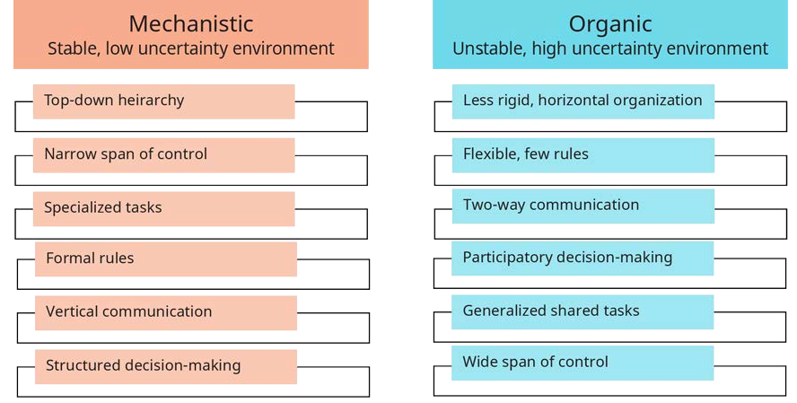
- What are some advantages and disadvantages of functional structures?
Advantages:
High specialization
Clear reporting lines
Economies of scale
Easy to scale as the organization grows
Disadvantages:
Departmental “silos” and poor communication
Slow decision-making
Weak inter-department coordination
Competition for resources and power

- What are some advantages and disadvantages of divisional structures?
Advantages of Divisional Structure
Focuses on specific markets or business segments
Improves specialization and budget control
Clear roles and responsibilities
Faster customer service
Better coordination within divisions
Supports decentralized decision-making
Suitable for large organizations
Disadvantages of Divisional Structure
Divisions may become isolated
Poor communication between divisions
Reduced coordination across the organization
Different systems may create inefficiencies
Difficult to maintain overall goals and consistency

- Explain how natural disasters and human-related environmental problems affect organizations and businesses.
Natural disasters and human-induced environmental problems include events such as hurricanes, extreme temperatures, rising CO₂ emissions, water and food crises, biodiversity loss, ecosystem collapse, and large-scale migration.
These risks significantly affect organizations, industries, and countries, and are increasing in both likelihood and impact.
Climate change is causing rising sea levels, threatening low-lying regions and islands, and damaging ecosystems and human health.
As a result, businesses face challenges such as environmental damage, legal actions, and Need for climate-resilient infrastructure.

